

**Report**

**ON**

**CSE327: Software Engineering**

**Project Name : Online Cleaning Service**

**Submitted By:**

**Sk. Azmiara Aumi Id-1722263642**

**Mosarrat Shazia Kabir**

**Id-1831228642**

**Syeda Karishma Naaz**

**Id-1831270642**

**Table of Contents**

**Acknowledgement**

**1. Introduction**

**2. Project Management**

**2.1. Process Model**

**3. Requirement Analysis**

**3.1. Product Functions**

**3.2. User Characteristics**

**3.3. Assumptions and Dependencies**

**3.5. Database Interfaces**

**3.6. Functional Requirements**

**3.6.1. Appointment**

**3.7. Performance Requirements**

**3.8. Data Requirements**

**4. Design**

**4.1. Data Design**

**4.2. Interface Design**

**5. Testing**

**6. Reference**

**Acknowledgement**

***We would like to express our special Thanks of gratitude to A K M Bahalul Haque (ABH3) Sir who gave us the opportunity to do the wonderful project on the Software Engineering (CSE327), which also helped us in Research and we came to know about so many new things. We are really thankful for him. It is his guidance and patience that led us to envision our project “Online Cleaning Service” to be a full-fledged solution for an online cleaning service appointment system.***

***Introduction***

The main aim of this project is to develop software for the process of appointment services and laundry which should lead to an easy life for everyone; specially for working people. It’s convenient for the customers to choose a particular service at home and they don’t need to go outside to give clothes for laundry. The software should control the process so that every customer should get the equal service. Service time and Transaction should be independent. Moreover, working people can’t have enough time for cleaning so cleaning service is the easiest way to make their home and office clean. Technical System is fast, reasonable and user friendly. The proposed system enables the customers to do things such as search for services that are available.The system displays all the descriptive details for a service such as price,measurement, appointment.

***Project Model***

Different phases of models:

**1. Software Requirements Analysis**

- In this, a software engineer understands the nature of a program to be built, he must understand the information domain for the software as well as required function, behavior, performance and interface. Requirements for both the system and software are documented and reviewed with the customer.

**2. Design**

- It has four distinct attributes of a program: data structure, software architecture, interface representations and procedural details. It is a documentary and becomes part of software.

**3. Code**

- Design must be translated into a machine readable from which is done by MySQL, XAMPP, Visual Studio.

**4. Testing**

- Software testing is done by using Selenium, Phpunit, Laravel.

**5. Support**

- This is a phase when software will undoubtedly undergo change after it is delivered to the customer. Change will occur because errors have been encountered, because the software must be adapted to accommodate changes in its external environment, or because the customer requires functional or performance enhancements. Software support/maintenance reapplies each of the preceding phases to an existing program rather than a new one.

***Requirement Analysis***

**Overall Description:**

**Product Functions:**

Our online cleaning service system is a web-based system. The customers can make appointments online. Admin can use the system to take appointments and cancel appointments which will update to the webpage. Also, the admin can check the statistical information from the system. The project is being developed keeping in mind the following objectives:

1. Reduce the paperwork & storage area.
2. Improve the output of operators.
3. Improve accuracy in result.
4. It has a user-friendly interface.
5. More security and safety of data.
6. Quick query processing.
7. Easy access to data.
8. Reliable and efficient.
9. Increase the processing speed.
10. Quick access to appropriate candidates.
11. Easy retrieval of information.

The features of this product are as follows:

1. Prevention against unauthorized access.

2. Prevention against spamming.

3. Easy navigation.

4. Online service booking of all types of cleaning at any time.

5. A presentable, fast and easy user interface.

6. Minimizes the number of staff at the booking cleaning service.

7. Online promotion of appointments and cleaning.

8. Obtains statistical information from the appointment record.

***User Characteristics:***

1. Customers use the system to fetch information about available service, their price.

2.Admin manages the system and keeps it up-to-date. Admin also looks over customers and organizers.

3.Organizers use the system to list their Appointed Dates, Cleaning criteria and other related information like availability, price, date and timings.

***Assumptions and Dependencies:***

* Admin is created in the system already.
* Roles and tasks are predefined.
* In general it has been assumed that a user has complete knowledge of the system that means the user is not a naïve user. Any data entered by him/her will be valid.
* It depends on whether one should fill the related information in the proper format.
* The Central Server of the system must be able to handle all the incoming requests simultaneously.
* Username defines our respective users.
* Administrator has the authority to reserve/cancel the service appointment.

***Database Interfaces:***

* All databases for the software will be configured. These databases include admins’ details database, appointments’ details database, category details database and services’ details database.
* The admins’ details database includes id, Full Name, User Name, Email, Password, image Name.
* The appointments’ details database includes is, service, price, price description, appointment on , measure, total, appointment made, status, customer name, customer contact, customer email, customer address.
* The category details include id, title, image name, active status.
* The services’ details database include id, title, description, price, price description, image name, category name, category title, active status.

***Functional Requirements:***

Appointment**:**

* This module basically deals with the appointment of services. It accepts appointment details, retrieves appointment details, processes the appointment based on customer requirements. After a successful service, databases are updated with a complete status.

Performance Requirements:

* Each component of the system can accept and work on only one service at a time. Internet access is required for choosing service, appointment form, and appointment process.

Data Requirements***:***

* The system can store the following data: id, full name, user name, email, contact number, address.
* Assuming a user has correctly authenticated him/her via confirmation message.
* The system will also maintain a backup database (local host).

**GitHub**

**Data Design**

**Admin:**

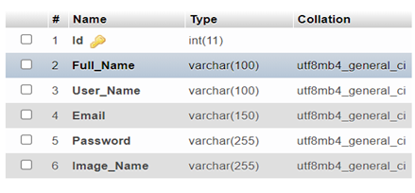

**Appointment:**

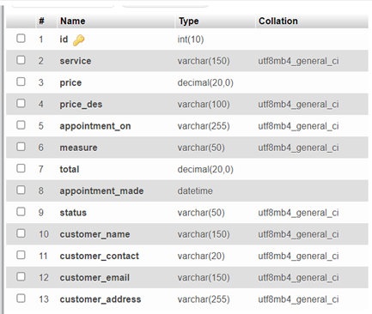

**Category:**

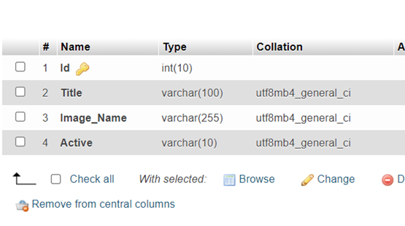

**Service:**

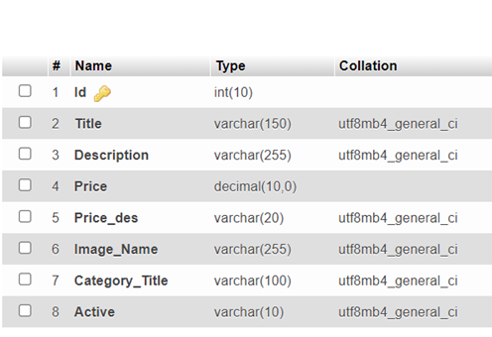

**Interface Design**

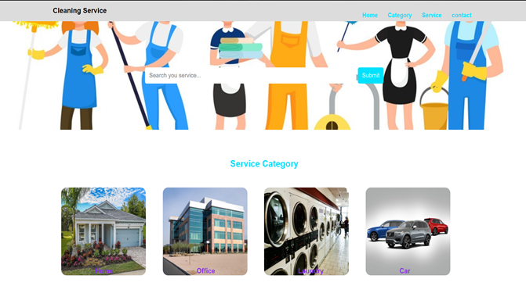

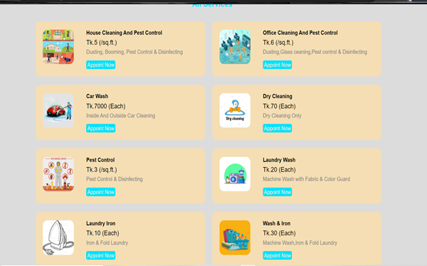

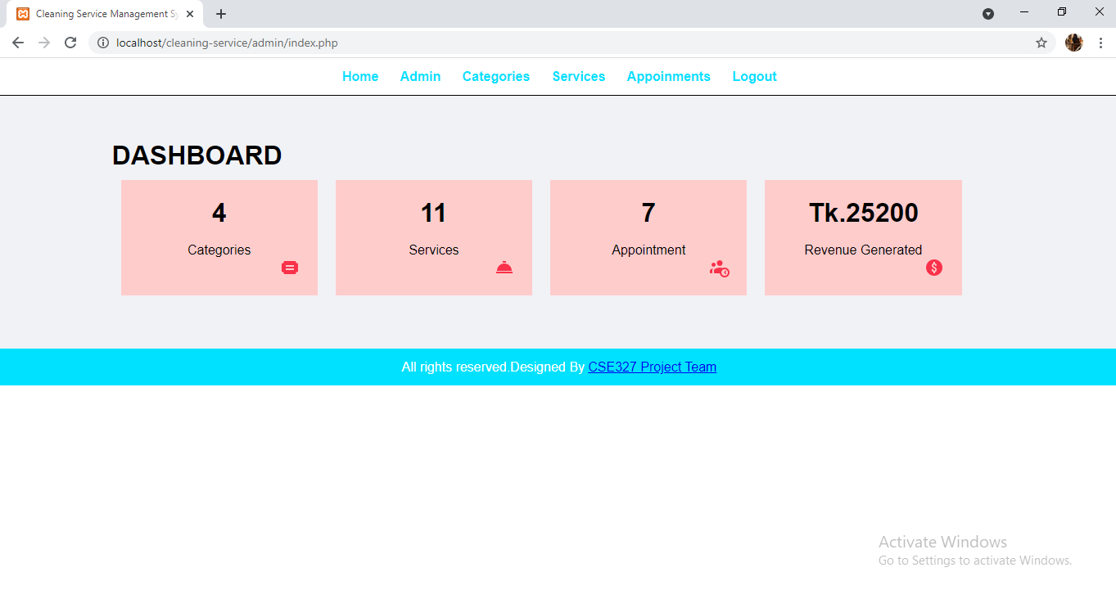

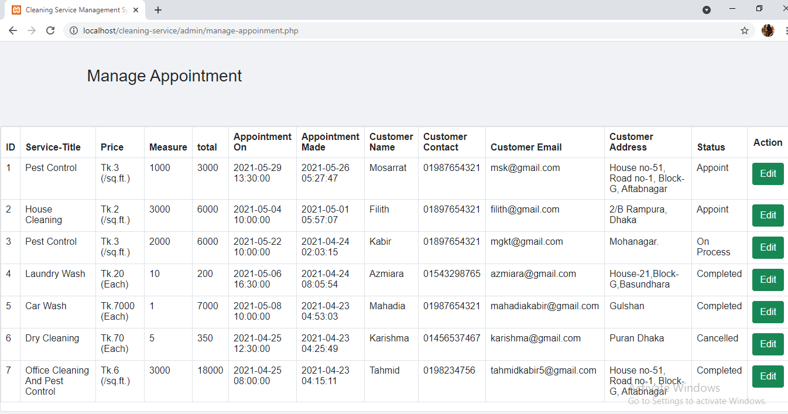

**Testing**

We did Interface testing by using eclipse and selenium. We tested every single code but we provided only our homepage testing portion .We attach our testing part and also include our result portion.

We did unit testing and databases by using PHPunit and Laravel.

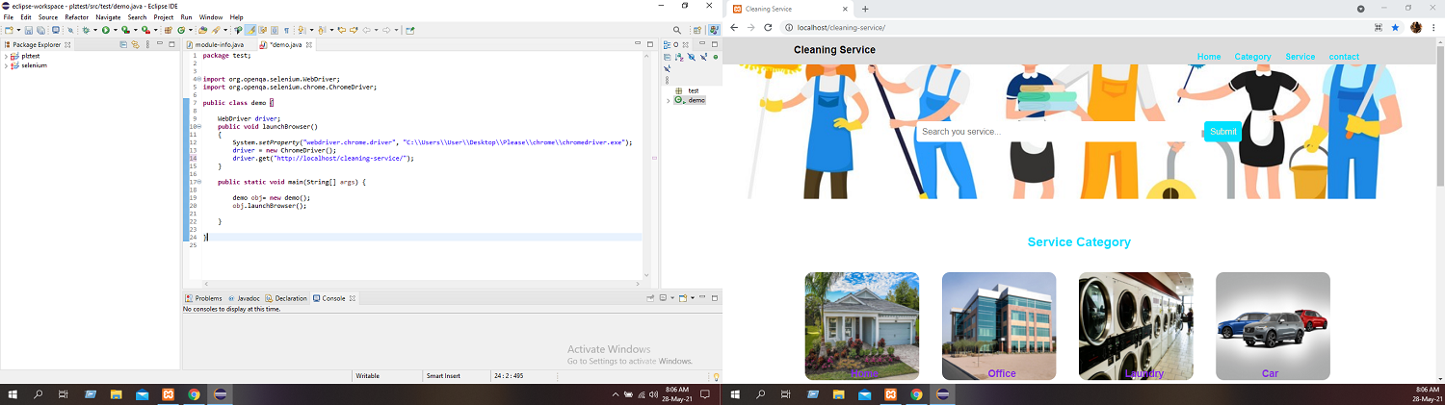



**Reference**

1. Php Programing Language:

* <https://www.youtube.com/watch?v=hx38tnlYGlA>
* https://www.w3schools.com/php/

1. Xampp:

* <https://www.youtube.com/watch?v=cGwSm8xDSwI>

1. Bootstrap:

* <https://www.youtube.com/watch?v=CMk8xB90RpU>
* <https://www.w3schools.com/bootstrap4/>

1. HTML & CSS :

* [**https://www.w3schools.com/html/**](https://www.w3schools.com/html/)
* [**https://www.w3schools.com/css/**](https://www.w3schools.com/css/)